

Name : Suyash Pawar

Roll No: 464

Prn No: 202201030036

Batch:D4

1.Import pandas as pd

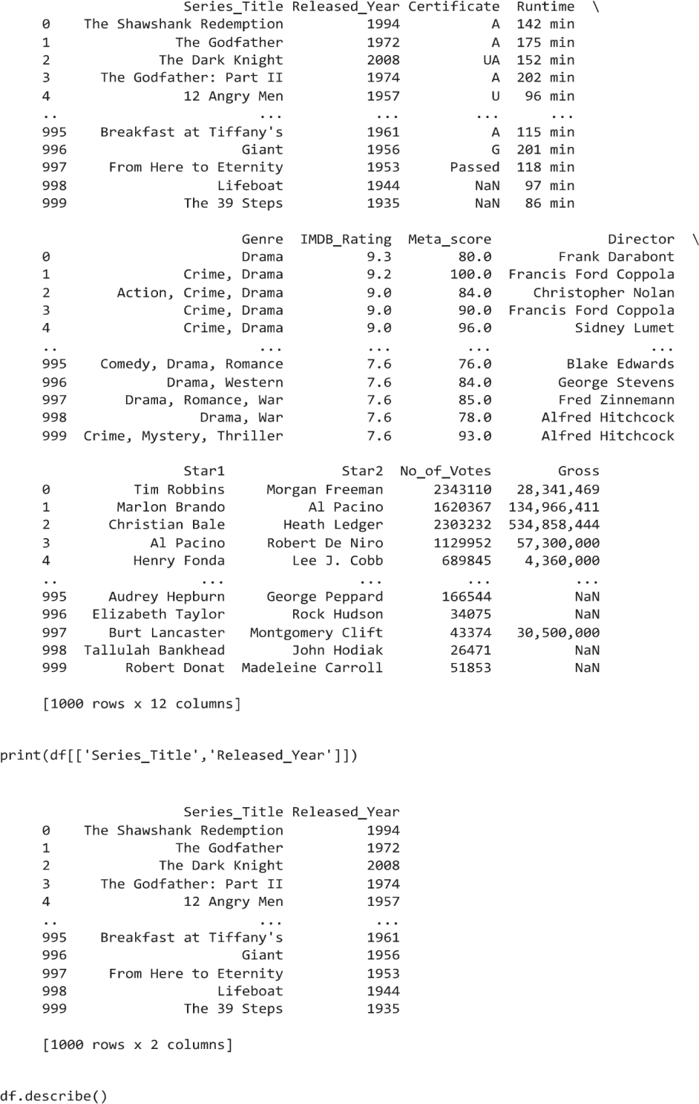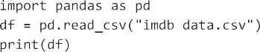

df = pd.read_csv(“imdb data.csv”) print(df)

3.

